Patrick Coulter

April 24, 2020

Tic Tac Toe

Tic Tac Toe is a game where two players alternate turns to complete a row, a column, or a diagonal with X’s and O’s. The space is a three by three grid in which to play on. The project was to program using some sort of an interface. Tic Tac Toe is a good example as it shows that anyone can use javafx to make the playing grid show when the program starts and the X’s and O’s whenever a keypress or mouse click is made. For this program the X’s and O’s are tied to a single mouse click and when the first X is placed it goes to O and alternates until there is a winner or a draw.

Private char whoseTurn = ‘X’ is what is declared to start the first mouse click with X. The 2d cell array is declared to show its a three by three grid we want to show when the program starts. Lable lblSratus is what shows in a text box at the bottom of the screen what player’s turn it is and who won or if it is a draw. The start method is what the program starts with when it is booted. The method goes through two for loop one for each part of the 2d array to declare the three by three grid. It then goes through and sets the center for each pane and the bottom for where the text box is located. The text box which is called lblStatus is set to a font size of 24 for easy reading but not too small you cannot read it and where the width of the text box. Then it runs through the seen giving the size of the window when launched and the title that is shown at the top.

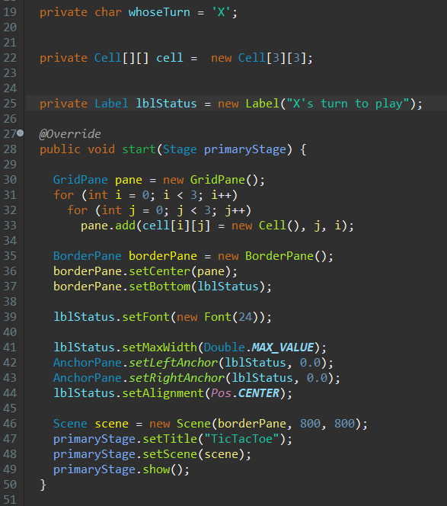

The program then runs through the isFull method which checks to see if all nine cells have an X or an O in then and if it is true the program writes in the text box that the game is over and ended in a draw. If the method is false it would go to the isWon method to see if there are three X’s or O’s in the 12 different possible configurations. If that method is false, the text indicated who the next player is.

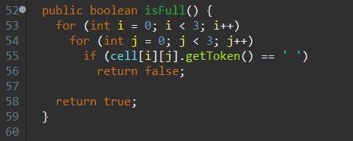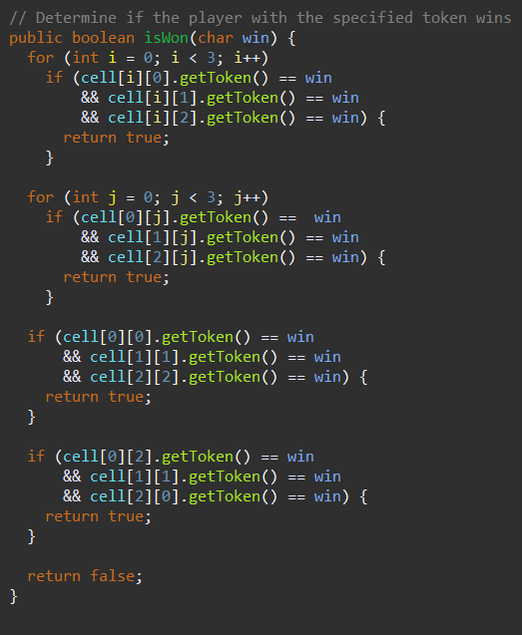

The getToken method gets the X or O and puts it into a varabile. The token is taken to the setToken method and if it equals X or O it draws it when a mouse press is made.

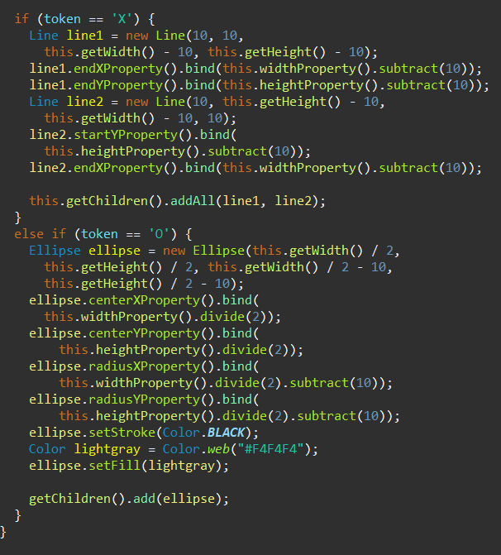

The handelMouseClick method handels all the mouse click events. It sets the left mosue click to whatever the token is equal to only if the grid isn’t full or there is a winner. If no winner it altimates them until there is a winner or a draw.

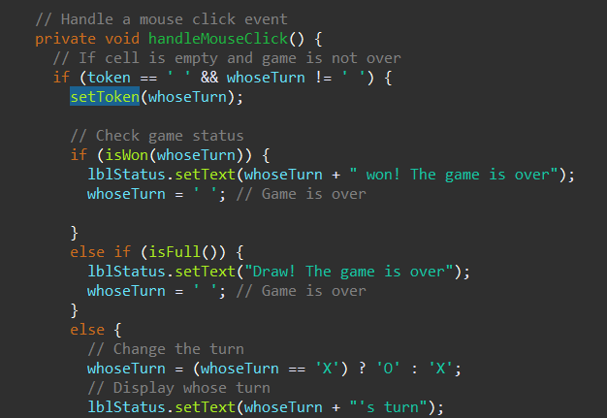

The X is what is placed into a cell when the mouse is clicked when it is X’s turn. The text at the bottom currently shows it is O’s turn but can display who won and if it is a draw.

